Chapter 3 - Relations Quiz
Use the following graph to answer the next 3 questions
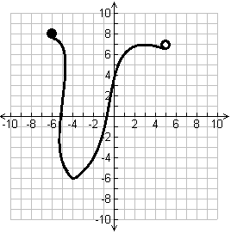
- Does the graph above represent a function?

- Determine the value of x if $f\left(x\right)=-6$

- Write the domain of the graph in set notation.

- Write the range of the graph in interval notation.

5. A computer technician charges a fee to make a house, call plus an additional hourly rate. If a one hour call costs $110 and a 2 hour call costs $150, create an equation in function to represent the Cost (C) as a function of time (t).

Chapter 3 - Relations Quiz
Use the following graph to answer the next 3 questions
- Does the graph above represent a function?

- Determine the value of x if $f\left(x\right)=-6$

- Write the domain of the graph in set notation.

- Write the range of the graph in interval notation.

5. A computer technician charges a fee to make a house, call plus an additional hourly rate. If a one hour call costs $110 and a 2 hour call costs $150, create an equation in function to represent the Cost (C) as a function of time (t).

